Make an Otter Puppet
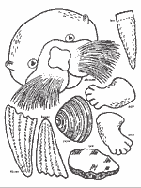
This paper bag puppet of an otter is easy to make – and did you know that an otter is an animal that really uses Resourcefulness every day?
The otter loves to eat crabs and clams, but has no way to open the hard shell. So he dives to the bottom, picks up a good rock, then returns to the surface and uses the rock to smash open his dinner!
Also, he uses special “pockets” – flaps of skin under each front leg, to stash his dinner during a dive.
And in one more example of resourcefulness, the otter floats on his back and uses his own stomach as a table!
Another resourceful habit of the otter – in order to catch a safe nap without floating away, he wraps himself in the kelp!
Here’s how to make your otter puppet.
For more information about sea otters, other activities and how to make your puppet, go to: www.montereybayaquarium.org/lc/activities/otter_puppet.asp

